Arctic Borderlands Ecological Knowledge Society, March 1, 2014, Temperatures at Inuvik, Indicator Report No. 02-2014, www.arcticborderlands.org/scientificindicators/
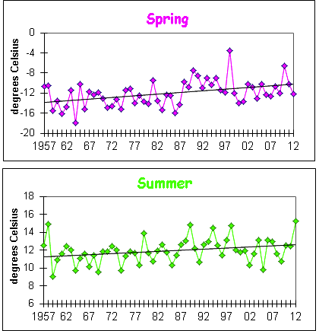
Temperatures at Inuvik
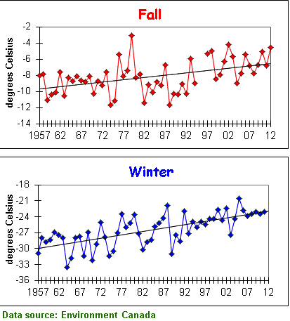
What is happening?
- This set of graphs shows average temperatures for spring, summer, fall and winter at Inuvik based on readings from 1957 to 2012.
- There was a significant increase in average temperature in all four seasons over time. The largest warming has occurred in winter where the average temperature has warmed 5 degrees Celsius over the last 40 years. Average summer temperatures, by comparison, have warmed the least at just 1 degree Celsius over the last 40 years.

Why is it happening?

- Increases in global mean temperatures have been predicted as a result of increases in atmospheric greenhouse gases generated by human activities. These changes have been predicted to be greatest in the polar regions.
- Temperature changes may also result from natural climate variations, such as the decrease in temperatures that brought about the "Little Ice Age" cooling period in the 19th century for much of the northern hemisphere.
- Annual variability in mean temperatures is often large, and the detection of trends in climate generally requires long-term data sets.

Why is it important?
- Changes in global and regional climate have important implications for many aspects of the environment. In the North, temperature warming may bring about changes in sea, river and lake ice, snow conditions, permafrost, habitat for plants and animals, and other changes. For human communities, this may mean changes in agricultural productivity, sustainable hunting levels, heating fuel consumption, and patterns of land use. These effects may be both positive and negative, and are likely to vary from region to region.
- One of the greatest concerns associated with human-induced global climate change is the rate of global temperature changes - temperatures in this region are expected to increase by at least as much and faster than after the last ice age (about 10,000 years ago).

Technical Notes

- Trends in temperature were tested using data obtained between 1957 and 2012 for all four seasons. The trend for each season at Inuvik was significant at p.<0.05.
- The data presented in these graphs are averages of mean monthly temperature data for March-May, June-August, September-November, and December-February, obtained from Environment Canada's homogenized data set. Winter means are calculated using December values of the current year, and January and February values of the following year.
- Missing data points are due to a lack of sufficient data to calculate seasonal averages for those years.

Links

- Long-term temperatures from tree rings
- Temperatures at Tuktoyaktuk
- Temperatures at Shingle Point
- Precipitation at Old Crow
- Old Crow River ice-free period

____________________________________________________________________________________

Data added: March 1, 2014.

